In our efforts to continuously improve, you will be asked to provide feedback through an online assessment. Please create a password and sign in to take five assessments. The assessments will take 5 – 10 minutes each.

The Assessments are completely anonymous. The only thing that will be known is whether or not you took the assessments and how long it took to take each. This helps us ensure we gather everyone’s input and the amount of effort required to provide that feedback.

Setting Up a Password
To begin, you will need to create a password. Follow these instructions to set up your secure login:
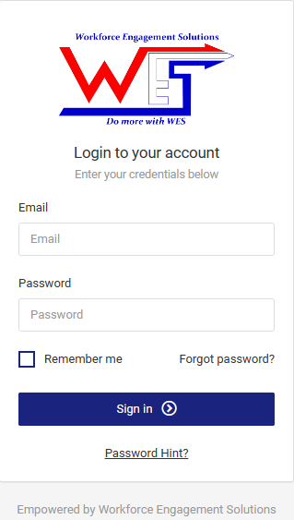
Access TheWEQ assessment page at: https://theweq.com/

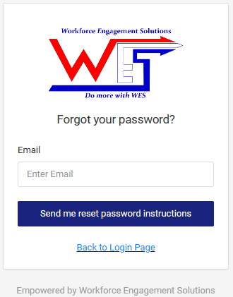
Set up a new password by clicking on “Forgot Password?” just above the Sign In button.

Enter Your E-Mail address and instructions will be sent to your account.

Follow the instructions and you should be ready to go!

A little bit more about the assessments:
The assessments will provide us insight regarding 50 Elements that impact our ability to efficiently achieve our goals and provide the opportunities for every employee to succeed.
There are 5 assessments that evaluate five stages of organizational maturity:
Stage 1: Forming Insight into how well we’ve defined our vision and value proposition, strategic resourcing and staffing, and bringing individuals together to begin transitioning into teams
Stage 2: Focusing How well we’ve developed systems and procedures, established goal and role clarification, solved any problems, and aligned our organization towards achieving our mission
Stage 3: Committing How we’ve built our team capabilities and proficiencies delivering on our value proposition and how empowered our teams feel embracing the mission as their own
Stage 4: Sustained Performance Whether we’ve effectively standardized our processes and procedures to ensure cohesiveness consistent delivery of value to our customers and stakeholders
Stage 5: Renewal Our capacity to sustain a culture of excellence through continuous improvements and empowering employees through development, compensation, and rewards, as well as proactive succession planning

Importance of Your Input
Your honest feedback is essential. The feedback you provide is completely anonymous and compiled into group reports. The only specific information received is whether you have completed a report and the length of time spent on each assessment. This information is available to help us ensure we gather everyone’s input.

If you have questions or need assistance, talk with your supervisor. If you need additional information click the “Using the Assessment Engine” link. This link is also available within the assessment application on the left hand menu by selecting the “Assessment Help” link.

Thanks for adding your feedback to those of your colleagues to help us improve. Once we have everyone’s input, we will share with you the full results and together we’ll determine our next steps.

